Clean Code Principles - Don’t Repeat Yourself (DRY)
# Source: AI Source: Provided by: [Data Path: Persons Table -> ID Column: 1, Name_En Column: Motasem Essam] -> From: [Chatgpt (GPT‑5 Mini)] on [12/9/2025]
The DRY principle states that every piece of knowledge or logic should exist in only one place in your codebase.

🔑 Why DRY Matters
# Source: AI Source: Provided by: [Data Path: Persons Table -> ID Column: 1, Name_En Column: Motasem Essam] -> From: [Chatgpt (GPT‑5 Mini)] on [12/9/2025]
- Reduces duplication and inconsistency
- Makes code easier to maintain and update
- Prevents bugs caused by copying code in multiple places
- Improves readability and structure

✅ Good Example
# Source: AI Source: Provided by: [Data Path: Persons Table -> ID Column: 1, Name_En Column: Motasem Essam] -> From: [Chatgpt (GPT‑5 Mini)] on [12/9/2025]
Reusable function instead of repeating logic:
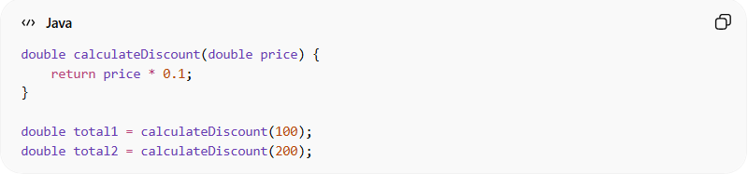
double calculateDiscount(double price) {
return price * 0.1;
}

double total1 = calculateDiscount(100);
double total2 = calculateDiscount(200);

❌ Bad Example
# Source: AI Source: Provided by: [Data Path: Persons Table -> ID Column: 1, Name_En Column: Motasem Essam] -> From: [Chatgpt (GPT‑5 Mini)] on [12/9/2025]
Duplicating the same logic in multiple places:
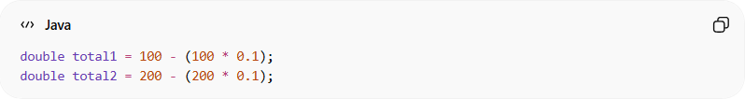
double total1 = 100 - (100 * 0.1);
double total2 = 200 - (200 * 0.1);
👉 The same calculation is repeated twice. If the logic changes, you must update it everywhere.

❌ Another Bad Example (Copy-Paste Code)
# Source: AI Source: Provided by: [Data Path: Persons Table -> ID Column: 1, Name_En Column: Motasem Essam] -> From: [Chatgpt (GPT‑5 Mini)] on [12/9/2025]
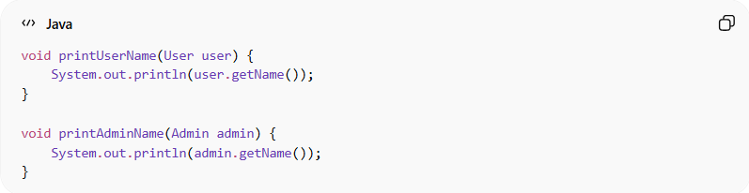
void printUserName(User user) {
System.out.println(user.getName());
}

void printAdminName(Admin admin) {
System.out.println(admin.getName());
}
👉 Same logic repeated with different types.

✅ Refactored (DRY Applied)
# Source: AI Source: Provided by: [Data Path: Persons Table -> ID Column: 1, Name_En Column: Motasem Essam] -> From: [Chatgpt (GPT‑5 Mini)] on [12/9/2025]
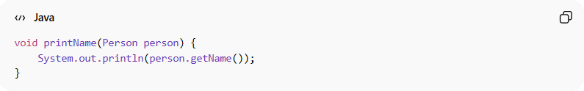
void printName(Person person) {
System.out.println(person.getName());
}

💡 Key Idea
# Source: AI Source: Provided by: [Data Path: Persons Table -> ID Column: 1, Name_En Column: Motasem Essam] -> From: [Chatgpt (GPT‑5 Mini)] on [12/9/2025]
If you write the same logic more than once, you should extract it into a reusable function, class, or module.

🚫 Common DRY Violations
# Source: AI Source: Provided by: [Data Path: Persons Table -> ID Column: 1, Name_En Column: Motasem Essam] -> From: [Chatgpt (GPT‑5 Mini)] on [12/9/2025]
- Copy-pasting code across files
- Repeating calculations or logic
- Duplicating validation rules
- Repeating configuration values instead of using constants

🧾 Summary
# Source: AI Source: Provided by: [Data Path: Persons Table -> ID Column: 1, Name_En Column: Motasem Essam] -> From: [Chatgpt (GPT‑5 Mini)] on [12/9/2025]
Following DRY helps you:
- Write cleaner and shorter code
- Reduce maintenance cost
- Avoid inconsistent logic
- Improve code reuse and scalability

